**AudioPad**

*(Just another notepad with voice extension)*

**COMSATS University Islamabad**

Sahiwal Campus



***Usama Sarwar***

FA17-BS(CS)-090-B

***Ahmad Shaf***

Software Design Methodology

September 30, 2019

Abstract

Voice recognition module as shown in Figure on next page used Microsoft Speech SDK as the voice recognition engine. When the application interface is switched on, a recognizable set of words will be stored in this voice recognition engine and the identification system will be activated. In the active state, the application of voice recognition will take any words spoken at the microphone and tried to match to one of the words that has been stored in the storage engine for speech recognition. If there are any words that match with the words spoken, the word will be returned in the form of characters to be used by the system. After that, the voice recognition application will be ready for the next input.

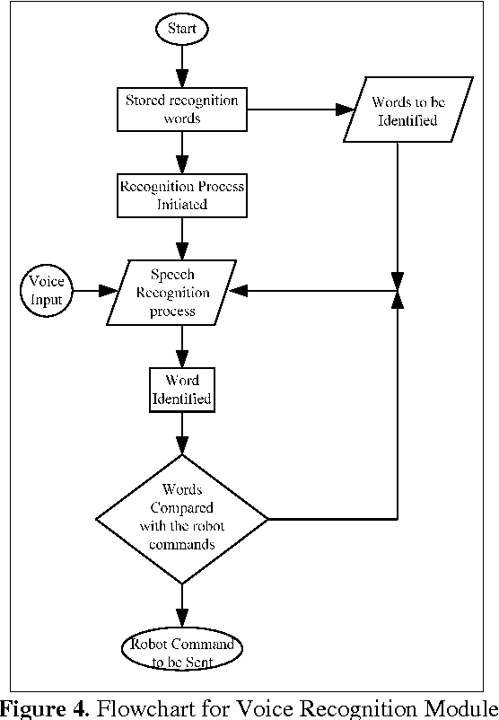

# Requirements

* + 1. Voice Input in English Accent
    2. Windows Operating System
       1. Windows 10 Professional (Recommended)
    3. Mic Device for Voice Input
       1. Noise Cancellation Mic. (Recommended)
    4. 512 MB RAM
    5. 512 MB ROM